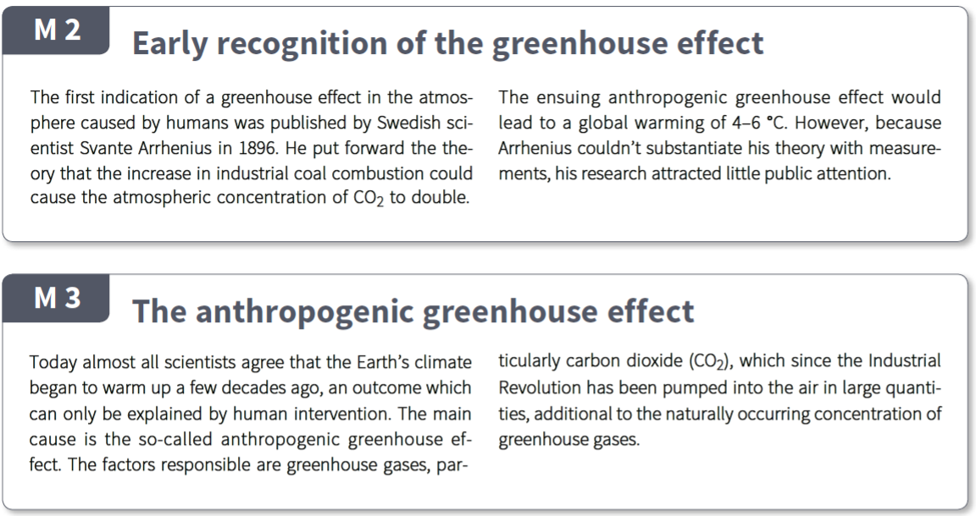
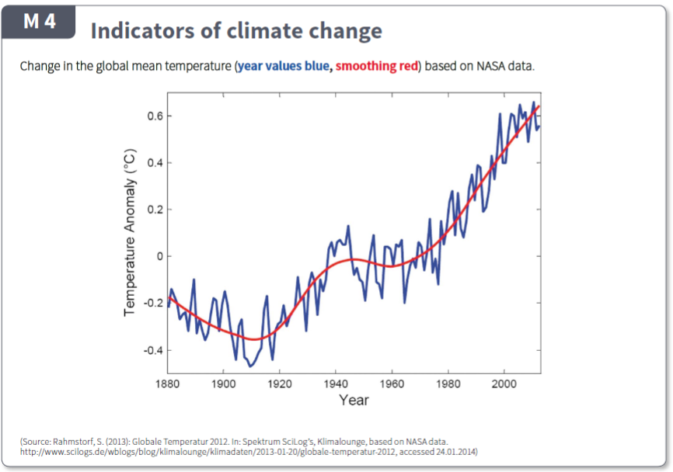
Questions
- Describe the general pattern you see in the graph in M4.
__________________________________________________________________________________________________________________________________________________________________________
- There are two periods of time where global temperature is dropping. The first (1880 to 1910) was caused by excess pollution which actually blocked solar radiation from reaching the earth. When pollution was reduced the earth started to warm again except for the middle of the 19th century – explain what happened at this time and why it would reduce greenhouse warming of the earth.
_______________________________________________________________________________________________________________________________________________________________________________________________________________________________________________________________

Questions
- Describe the general pattern you see in the graph in M4.
____________________________________________________________________________________________________________________________________________________________________
- There are two periods of time where global temperature is dropping. The first (1880 to 1910) was caused by excess pollution which actually blocked solar radiation from reaching the earth. When pollution was reduced the earth started to warm again except for the middle of the 19th century – explain what happened at this time and why it would reduce greenhouse warming of the earth.
_______________________________________________________________________________________________________________________________________________________________________________________________________________________________________________________________
_____________________________________________________________________________________
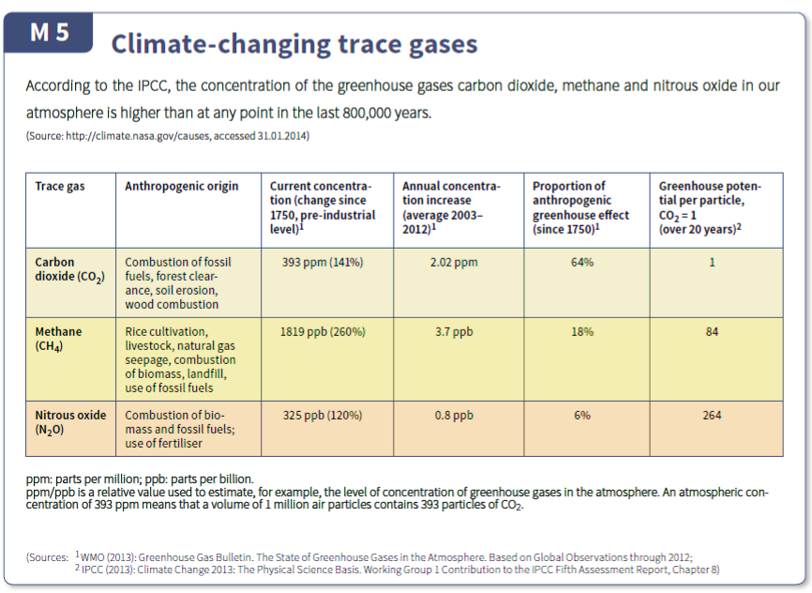
Questions
- In M5 the concentration of Methane is 1819ppb and Nitrous oxide is 325ppb. Convert both these values to ppm (divide by 100). Compare them to the concentration of CO₂ – how much more CO₂ is there than methane and Nitrous oxide?
__________________________________________________________________________________________________________________________________________________________________________
- Column 6 (far right column) in M5 indicates that Nitrous oxide is a far more dangerous greenhouse gas than either CO₂ or Methane. Use your answer in question 1 to explain why CO₂ is consider the “worst” greenhouse gas.
_______________________________________________________________________________________________________________________________________________________________________________________________________________________________________________________________
- Look at column 2 – the man made (anthropogenic) causes of these gases being in the atmosphere. What would you recommend we do to reduce the emissions of the gases? Explain why you think this.
_______________________________________________________________________________________________________________________________________________________________________________________________________________________________________________________________
_____________________________________________________________________________________

